**A COMPEREHENSIVE ANALYSIS OF FINANCIAL PERFORMANCE: INSIGHTS FROM A LEADING BANKS**

**Team ID :** NM2023TMID05408



**SUBMITTED BY**

**TEAM LEADER: ATHIRA.P. P**

**NM_ID: 9656F1EDB550A9F955F449FA4E023615**

**TEAM MEMBERS: 1. KANISHMA. K. A**

**2.SATHIYA.J**

**3.VARSHAA.R. K**

**A COMPEREHENSIVE ANALYSIS OF FINANCIAL PERFORMANCE: INSIGHTS FROM A LEADING BANKS**

1.INTRODUCTION:



1.1 OVERVIEW:

Banks are susceptible to a range of risks. Banking problems can often be traced to a decrease the value of bank’s assets. When assets value decreases substantially a bank can end up with liabilities that are bigger than its assets.



1.2 PURPOSE:

To analysis the bank related data and able to extract some insights from the data using Business Intelligence tools. By analysis the bank data offers management strategies as solutions and conclusion.

2.PROBLEM DEFINITION AND DESIGN THINKING:



2.1 EMPATHY MAP: 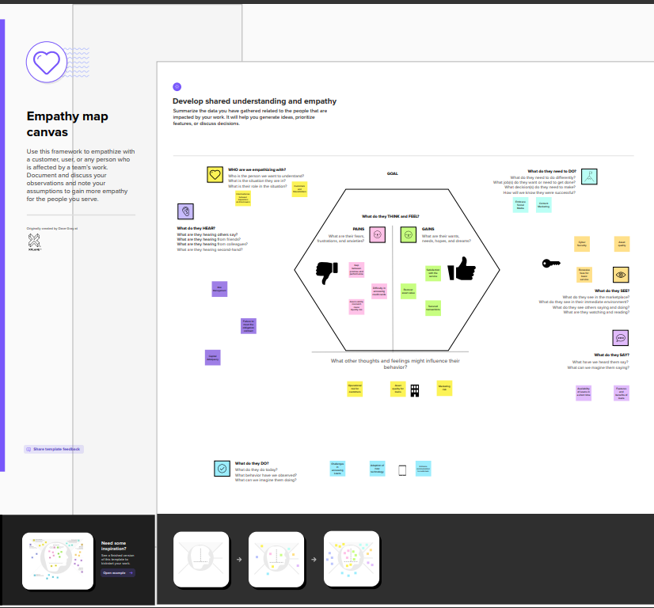

2.2 IDEATION & BRAINSTORMING MAP:

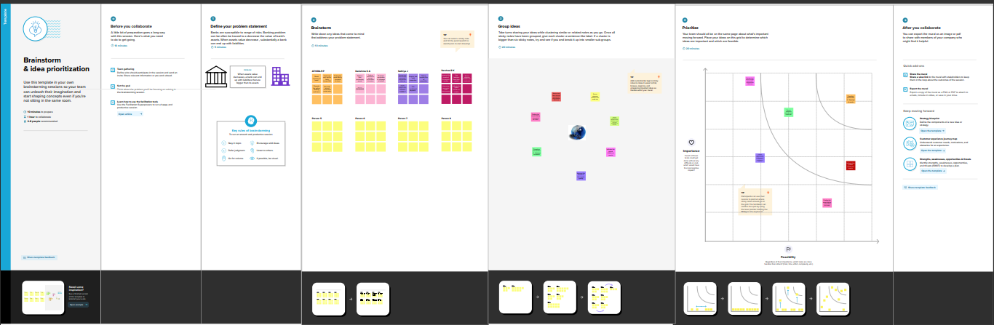

3.RESULT:

3.1 DASHBOARD 1:

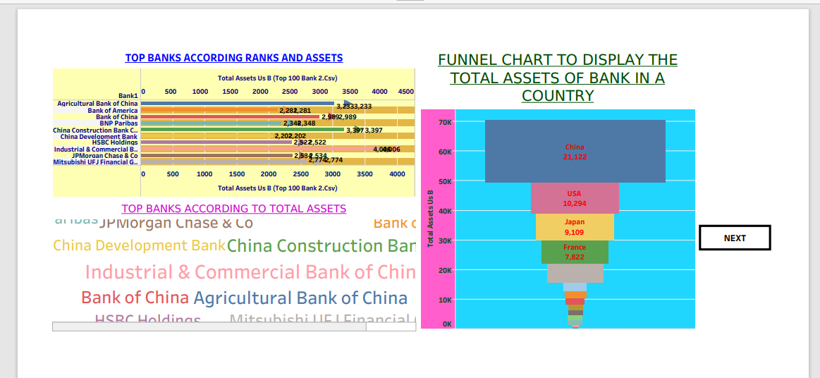

3.1 DASHBOARD 2:

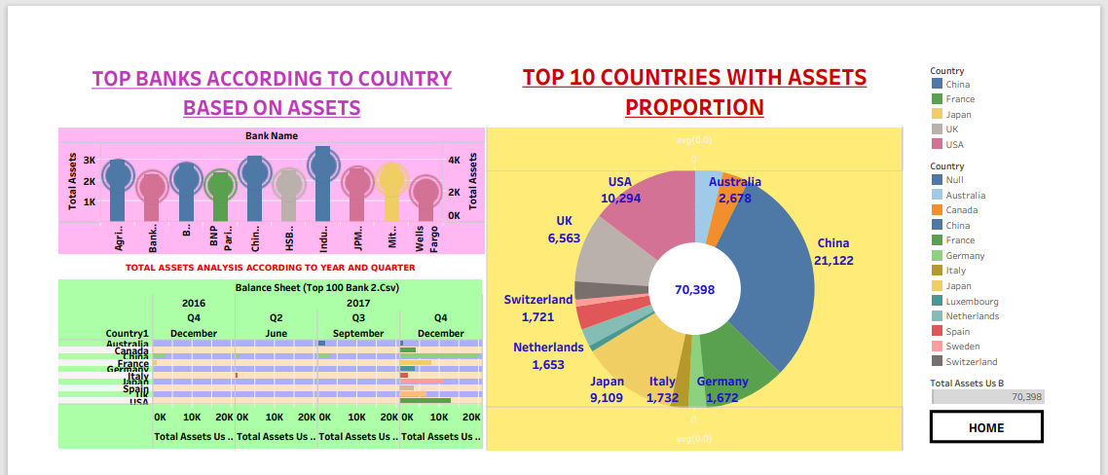

3.2 STORY: 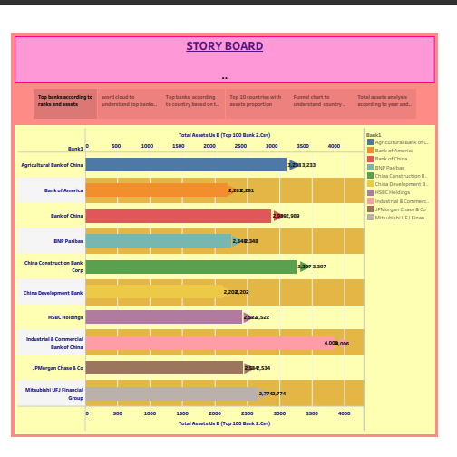

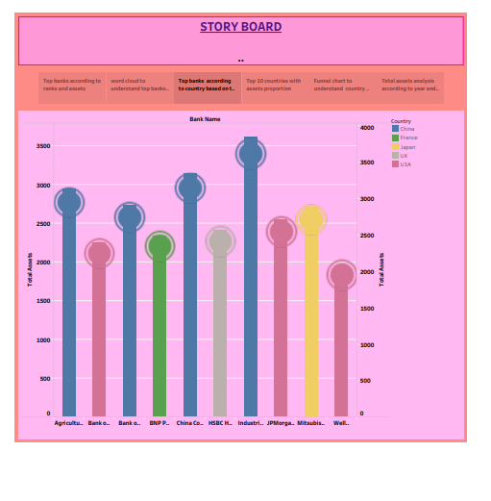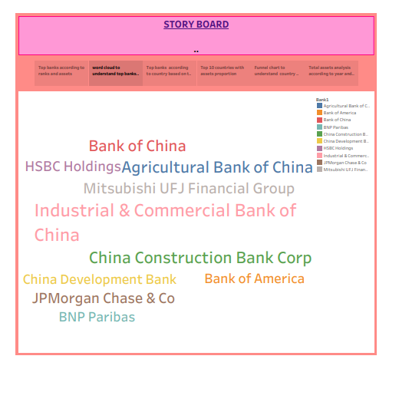

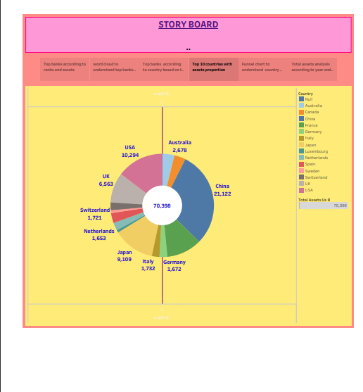

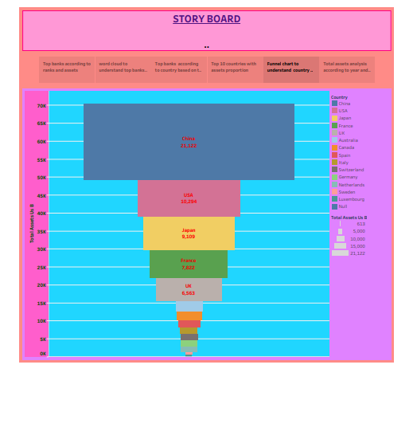

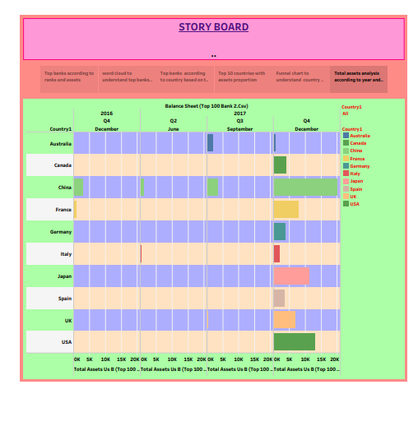

4.ADVANTAGES AND DISADVANTAGES:



|  |
| --- |
| ADVANTAGES:  Assets are important as they can help you to, generate revenue increase your business value help the running of your business. Assets value can be increased by improving the assets quality. Proactive prevention of slippage of assets; talking borrowers to prevent accumulation of overdue. We can find the asset-liability mismatch for loans in banks. We can empathize customers and shareholders. We increase the quality of features and benefits in banks by analysis. |
| DISADVANTAGES:  There may be a marketing risk in assets. There also credit risk, operational risk, risk management, etc... Bank regulates the standards for assets that includes measures for capital adequacy, liquidity, and leverage. |

5.APPLICATION:

In corporate finance, the analysis is conducted internally by the accounting department and shared with management in order to improve business decision making.

One of the most common ways to analyze financial data is to calculate ratios from the data in financial statements to compare against those of other companies or against the company’s own historical performance.

In investment finance, an analyst external to the company conducts an analysis for investment purposes.



6.CONCLUSION:



By analysis the data using data visualization we can conclude the result easily. We find the problem and lower the risk factor in any kind of investment. We can maintain the financial management. Proper financial management ensures the economic growth and stability of an organization.

7.FUTURE SCOPE: 

Financial analysis can help fund managers make future business decisions or review historical trends for past successes. It can increase the efficiency of business operations.

8.APPENDIX:

<!DOCTYPE html>

<html lang="en">

<head>

  <meta charset="utf-8">

  <meta content="width=device-width, initial-scale=1.0" name="viewport">

  <title>Fin Analytica</title>

  <meta content="" name="description">

  <meta content="" name="keywords">

  <!-- Favicons -->

  <link href="assets/img/favicon.png" rel="icon">

  <link href="assets/img/apple-touch-icon.png" rel="apple-touch-icon">

  <!-- Google Fonts -->

  <link rel="preconnect" href="https://fonts.googleapis.com">

  <link rel="preconnect" href="https://fonts.gstatic.com" crossorigin>

  <link href="https://fonts.googleapis.com/css2?family=Open+Sans:ital,wght@0,300;0,400;0,500;0,600;0,700;1,300;1,400;1,600;1,700&family=Montserrat:ital,wght@0,300;0,400;0,500;0,600;0,700;1,300;1,400;1,500;1,600;1,700&family=Raleway:ital,wght@0,300;0,400;0,500;0,600;0,700;1,300;1,400;1,500;1,600;1,700&display=swap" rel="stylesheet">

  <!-- Vendor CSS Files -->

  <link href="assets/vendor/bootstrap/css/bootstrap.min.css" rel="stylesheet">

  <link href="assets/vendor/bootstrap-icons/bootstrap-icons.css" rel="stylesheet">

  <link href="assets/vendor/aos/aos.css" rel="stylesheet">

  <link href="assets/vendor/glightbox/css/glightbox.min.css" rel="stylesheet">

  <link href="assets/vendor/swiper/swiper-bundle.min.css" rel="stylesheet">

  <!-- Template Main CSS File -->

  <link href="assets/css/main.css" rel="stylesheet">

  <!-- =======================================================

  * Template Name: Impact

  * Updated: Mar 10 2023 with Bootstrap v5.2.3

  * Template URL: https://bootstrapmade.com/impact-bootstrap-business-website-template/

  * Author: BootstrapMade.com

  * License: https://bootstrapmade.com/license/

  ======================================================== -->

</head>

<body>

  <!-- ======= Header ======= -->

  <section id="topbar" class="topbar d-flex align-items-center">

    <div class="container d-flex justify-content-center justify-content-md-between">

      <div class="contact-info d-flex align-items-center">

        <i class="bi bi-envelope d-flex align-items-center"><a href="mailto:contact@example.com">finanalytica@gmail.com</a></i>

        <i class="bi bi-phone d-flex align-items-center ms-4"><span>+91 99999 88888</span></i>

      </div>

      <div class="social-links d-none d-md-flex align-items-center">

        <a href="#" class="twitter"><i class="bi bi-twitter"></i></a>

        <a href="#" class="facebook"><i class="bi bi-facebook"></i></a>

        <a href="#" class="instagram"><i class="bi bi-instagram"></i></a>

        <a href="#" class="linkedin"><i class="bi bi-linkedin"></i></i></a>

      </div>

    </div>

  </section><!-- End Top Bar -->

  <header id="header" class="header d-flex align-items-center">

    <div class="container-fluid container-xl d-flex align-items-center justify-content-between">

      <a href="index.html" class="logo d-flex align-items-center">

        <!-- Uncomment the line below if you also wish to use an image logo -->

        <!-- <img src="assets/img/logo.png" alt=""> -->

        <h1>Financial Analysis<span>.</span></h1>

      </a>

      <nav id="navbar" class="navbar">

        <ul>

          <li><a href="hero">Home</a></li>

          <li><a href="#about">About</a></li>

          <li><a href="#dashboard">Dashboard</a></li>

          <li><a href="#story">Story</a></li>

          <li><a href="#contact">Contact</a></li>

        </ul>

      </nav><!-- .navbar -->

      <i class="mobile-nav-toggle mobile-nav-show bi bi-list"></i>

      <i class="mobile-nav-toggle mobile-nav-hide d-none bi bi-x"></i>

    </div>

  </header><!-- End Header -->

  <!-- End Header -->

  <!-- ======= Hero Section ======= -->

  <section id="hero" class="hero">

    <div class="container position-relative">

      <div class="row gy-5" data-aos="fade-in">

        <div class="col-lg-6 order-2 order-lg-1 d-flex flex-column justify-content-center text-center text-lg-start">

          <h2>Welcome to <span>Fin Analytica</span></h2>

          <p>A Widely used approach to analyzing a bank, CAMELS, considers a bank's Capital adequacy, Asset quality, Management capabilities, Earnings sufficiency, Liquidity position, and Sensitivity to market risk</p>

          <div class="d-flex justify-content-center justify-content-lg-start">

            <a href="#about" class="btn-get-started">Get Started</a>

            <a href="https://www.youtube.com/watch?v=LXb3EKWsInQ" class="glightbox btn-watch-video d-flex align-items-center"><i class="bi bi-play-circle"></i><span>Watch Video</span></a>

          </div>

        </div>

        <div class="col-lg-6 order-1 order-lg-2">

          <img src="assets/img/hero-img.svg" class="img-fluid" alt="" data-aos="zoom-out" data-aos-delay="100">

        </div>

      </div>

    </div>

    <div class="icon-boxes position-relative">

      <div class="container position-relative">

        <div class="row gy-4 mt-5">

          <div class="col-xl-3 col-md-6" data-aos="fade-up" data-aos-delay="100">

            <div class="icon-box">

              <div class="icon"><i class="bi bi-easel"></i></div>

              <h4 class="title"><a href="" class="stretched-link">Statiscal analysis</a></h4>

            </div>

          </div><!--End Icon Box -->

          <div class="col-xl-3 col-md-6" data-aos="fade-up" data-aos-delay="200">

            <div class="icon-box">

              <div class="icon"><i class="bi bi-gem"></i></div>

              <h4 class="title"><a href="" class="stretched-link">Data Visualization</a></h4>

            </div>

          </div><!--End Icon Box -->

          <div class="col-xl-3 col-md-6" data-aos="fade-up" data-aos-delay="300">

            <div class="icon-box">

              <div class="icon"><i class="bi bi-geo-alt"></i></div>

              <h4 class="title"><a href="" class="stretched-link">Machine Learning</a></h4>

            </div>

          </div><!--End Icon Box -->

          <div class="col-xl-3 col-md-6" data-aos="fade-up" data-aos-delay="500">

            <div class="icon-box">

              <div class="icon"><i class="bi bi-command"></i></div>

              <h4 class="title"><a href="" class="stretched-link">Artifical Intelligence</a></h4>

            </div>

          </div><!--End Icon Box -->

        </div>

      </div>

    </div>

    </div>

  </section>

  <!-- End Hero Section -->

  <main id="main">

    <!-- ======= about us Section ======= -->

    <section id="about us" class="about us">

      <div class="container" data-aos="fade-up">

        <div class="section-header">

          <h2>About Us</h2>

          <p>We provide best intelligence solutions to the companies, which makes a strategy for elevating their Business in the market. </p>

        </div>

        <div class="row gy-4">

          <div class="col-lg-6">

            <h3>Insight generations through sophasticated tools</h3>

            <img src="assets/img/about.jpg" class="img-fluid rounded-4 mb-4" alt="">

          </div>

          <div class="col-lg-6">

            <div class="content ps-0 ps-lg-5">

              <p class="fst-italic">

                We provide business solutions in various domains

              </p>

              <ul>

                <li><i class="bi bi-check-circle-fill"></i> Insights generations using Business Intelligence.</li>

                <li><i class="bi bi-check-circle-fill"></i> Building Data models using Statistics.</li>

                <li><i class="bi bi-check-circle-fill"></i> Developing the predictive models.</li>

              </ul>

              <div class="position-relative mt-4">

                <img src="assets/img/about-2.jpg" class="img-fluid rounded-4" alt="">

                <a href="https://www.youtube.com/watch?v=LXb3EKWsInQ" class="glightbox play-btn"></a>

              </div>

              </div>

            </div>

          </div>

        </div>

      </div>

    </section><!-- End about us Section -->

    <!-- ======= Stats Counter Section ======= -->

    <section id="stats-counter" class="stats-counter">

      <div class="container" data-aos="fade-up">

        <div class="row gy-4 align-items-center">

          <div class="col-lg-6">

            <img src="assets/img/stats-img.svg" alt="" class="img-fluid">

          </div>

          <div class="col-lg-6">

            <div class="stats-item d-flex align-items-center">

              <span data-purecounter-start="0" data-purecounter-end="1000000" data-purecounter-duration="1" class="purecounter"></span>

              <p><strong>Students</strong> has successfully trained</p>

            </div><!-- End Stats Item -->

            <div class="stats-item d-flex align-items-center">

              <span data-purecounter-start="0" data-purecounter-end="300" data-purecounter-duration="1" class="purecounter"></span>

              <p><strong>Projects</strong> has been developed</p>

            </div><!-- End Stats Item -->

            <div class="stats-item d-flex align-items-center">

              <span data-purecounter-start="0" data-purecounter-end="10000" data-purecounter-duration="1" class="purecounter"></span>

              <p><strong>Hours Of Support</strong> has been delivered</p>

            </div><!-- End Stats Item -->

          </div>

        </div>

      </div>

    </section>

    <!--End  counter Section-->

    <!-- =======  Dashboard Section ======= -->

    <section id="Dashboard class="Dashboard sections-bg">

      <div class="container" data-aos="fade-up">

        <div class="section-header">

          <h2>Analysis Dashboard</h2>

          <div class='tableauPlaceholder' id='viz1681225614496' style='position: relative'><noscript><a href='#'><img alt='FINANCIAL ANALYSIS OF BANKS ' src='https:&#47;&#47;public.tableau.com&#47;static&#47;images&#47;TA&#47;TASK3DASHBOARD_16807042218820&#47;Dashboard1&#47;1_rss.png' style='border: none' /></a></noscript><object class='tableauViz'  style='display:none;'><param name='host_url' value='https%3A%2F%2Fpublic.tableau.com%2F' /> <param name='embed_code_version' value='3' /> <param name='site_root' value='' /><param name='name' value='TASK3DASHBOARD_16807042218820&#47;Dashboard1' /><param name='tabs' value='no' /><param name='toolbar' value='yes' /><param name='static_image' value='https:&#47;&#47;public.tableau.com&#47;static&#47;images&#47;TA&#47;TASK3DASHBOARD_16807042218820&#47;Dashboard1&#47;1.png' /> <param name='animate_transition' value='yes' /><param name='display_static_image' value='yes' /><param name='display_spinner' value='yes' /><param name='display_overlay' value='yes' /><param name='display_count' value='yes' /><param name='language' value='en-US' /></object></div>                <script type='text/javascript'>                    var divElement = document.getElementById('viz1681225614496');                    var vizElement = divElement.getElementsByTagName('object')[0];                    vizElement.style.width='100%';vizElement.style.height=(divElement.offsetWidth*0.75)+'px';                    var scriptElement = document.createElement('script');                    scriptElement.src = 'https://public.tableau.com/javascripts/api/viz_v1.js';                    vizElement.parentNode.insertBefore(scriptElement, vizElement);                </script>

        </div>

        </div>

      </div>

    </div class="container">

    </section>

    <!---- End  Dahboard Section---->

    <!-- ======= Story Section ======= -->

    <section id="Story" class="Story sections-bg">

      <div class="container" data-aos="fade-up">

        <div class="section-header">

          <h2>Dashboard</h2>

          <div class='tableauPlaceholder' id='viz1681225829605' style='position: relative'><noscript><a href='#'><img alt='STORY BOARDStory Board for Financial Analysis of Banks ' src='https:&#47;&#47;public.tableau.com&#47;static&#47;images&#47;TA&#47;TASK3TABLEAUE&#47;StoryBoard&#47;1_rss.png' style='border: none' /></a></noscript><object class='tableauViz'  style='display:none;'><param name='host_url' value='https%3A%2F%2Fpublic.tableau.com%2F' /> <param name='embed_code_version' value='3' /> <param name='site_root' value='' /><param name='name' value='TASK3TABLEAUE&#47;StoryBoard' /><param name='tabs' value='no' /><param name='toolbar' value='yes' /><param name='static_image' value='https:&#47;&#47;public.tableau.com&#47;static&#47;images&#47;TA&#47;TASK3TABLEAUE&#47;StoryBoard&#47;1.png' /> <param name='animate_transition' value='yes' /><param name='display_static_image' value='yes' /><param name='display_spinner' value='yes' /><param name='display_overlay' value='yes' /><param name='display_count' value='yes' /><param name='language' value='en-US' /></object></div>                <script type='text/javascript'>                    var divElement = document.getElementById('viz1681225829605');                    var vizElement = divElement.getElementsByTagName('object')[0];                    vizElement.style.width='1016px';vizElement.style.height='991px';                    var scriptElement = document.createElement('script');                    scriptElement.src = 'https://public.tableau.com/javascripts/api/viz_v1.js';                    vizElement.parentNode.insertBefore(scriptElement, vizElement);                </script>

        </div>

      </section><!-- End Story Section -->

    <!-- ======= Contact Section ======= -->

    <section id="contact" class="contact">

      <div class="container" data-aos="fade-up">

        <div class="section-header">

          <h2>Contact</h2>

        </div>

        <div class="row gx-lg-0 gy-4">

          <div class="col-lg-4">

            <div class="info-container d-flex flex-column align-items-center justify-content-center">

              <div class="info-item d-flex">

                <i class="bi bi-geo-alt flex-shrink-0"></i>

                <div>

                  <h4>Location:</h4>

                  <p>A108 Adam Street, New York, NY 535022</p>

                </div>

              </div><!-- End Info Item -->

              <div class="info-item d-flex">

                <i class="bi bi-envelope flex-shrink-0"></i>

                <div>

                  <h4>Email:</h4>

                  <p>finanalytica@gmail.com</p>

                </div>

              </div><!-- End Info Item -->

              <div class="info-item d-flex">

                <i class="bi bi-phone flex-shrink-0"></i>

                <div>

                  <h4>Call:</h4>

                  <p>+91 99999 88888</p>

                </div>

              </div><!-- End Info Item -->

              <div class="info-item d-flex">

                <i class="bi bi-clock flex-shrink-0"></i>

                <div>

                  <h4>Open Hours:</h4>

                  <p></p>

                </div>

              </div><!-- End Info Item -->

            </div>

          </div>

          <div class="col-lg-8">

            <form action="forms/contact.php" method="post" role="form" class="php-email-form">

              <div class="row">

                <div class="col-md-6 form-group">

                  <input type="text" name="name" class="form-control" id="name" placeholder="Your Name" required>

                </div>

                <div class="col-md-6 form-group mt-3 mt-md-0">

                  <input type="email" class="form-control" name="email" id="email" placeholder="Your Email" required>

                </div>

              </div>

              <div class="form-group mt-3">

                <input type="text" class="form-control" name="subject" id="subject" placeholder="Subject" required>

              </div>

              <div class="form-group mt-3">

                <textarea class="form-control" name="message" rows="7" placeholder="Message" required></textarea>

              </div>

              <div class="my-3">

                <div class="loading">Loading</div>

                <div class="error-message"></div>

                <div class="sent-message">Your message has been sent. Thank you!</div>

              </div>

              <div class="text-center"><button type="submit">Send Message</button></div>

            </form>

          </div><!-- End Contact Form -->

        </div>

      </div>

    </section><!-- End Contact Section -->

  </main><!-- End #main -->

  <!-- ======= Footer ======= -->

  <footer id="footer" class="footer">

    <div class="container">

      <div class="row gy-4">

        <div class="col-lg-5 col-md-12 footer-info">

          <a href="index.html" class="logo d-flex align-items-center">

            <span>Fin Analytica</span>

          </a>

          <p>We provide solutions to your business.</p>

          <div class="social-links d-flex mt-4">

            <a href="#" class="twitter"><i class="bi bi-twitter"></i></a>

            <a href="#" class="facebook"><i class="bi bi-facebook"></i></a>

            <a href="#" class="instagram"><i class="bi bi-instagram"></i></a>

            <a href="#" class="linkedin"><i class="bi bi-linkedin"></i></a>

          </div>

        </div>

        <div class="col-lg-2 col-6 footer-links">

          <h4>Useful Links</h4>

          <ul>

            <li><a href="#">Home</a></li>

            <li><a href="#">About us</a></li>

            <li><a href="#">Services</a></li>

            <li><a href="#">Terms of service</a></li>

            <li><a href="#">Privacy policy</a></li>

          </ul>

        </div>

        <div class="col-lg-2 col-6 footer-links">

          <h4>Our Services</h4>

          <ul>

            <li><a href="#">Data Science</a></li>

            <li><a href="#">Artifical Intelligence</a></li>

            <li><a href="#">Business Intelligence</a></li>

            <li><a href="#">Data Analytics</a></li>

            <li><a href="#">Cloud Application Development</a></li>

          </ul>

        </div>

        <div class="col-lg-3 col-md-12 footer-contact text-center text-md-start">

          <h4>Contact Us</h4>

          <p>

            A108 Adam Street <br>

            New York, NY 535022<br>

            United States <br><br>

            <strong>Phone:</strong>+91 99999 88888<br>

            <strong>Email:</strong> finanalytica@gmail.com<br>

          </p>

        </div>

      </div>

    </div>

    <div class="container mt-4">

      <div class="copyright">

        &copy; Copyright <strong><span>Impact</span></strong>. All Rights Reserved

      </div>

      <div class="credits">

        <!-- All the links in the footer should remain intact. -->

        <!-- You can delete the links only if you purchased the pro version. -->

        <!-- Licensing information: https://bootstrapmade.com/license/ -->

        <!-- Purchase the pro version with working PHP/AJAX contact form: https://bootstrapmade.com/impact-bootstrap-business-website-template/ -->

        Designed by <a href="https://bootstrapmade.com/">BootstrapMade</a>

      </div>

    </div>

  </footer><!-- End Footer -->

  <!-- End Footer -->

  <a href="#" class="scroll-top d-flex align-items-center justify-content-center"><i class="bi bi-arrow-up-short"></i></a>

  <div id="preloader"></div>

  <!-- Vendor JS Files -->

  <script src="assets/vendor/bootstrap/js/bootstrap.bundle.min.js"></script>

  <script src="assets/vendor/aos/aos.js"></script>

  <script src="assets/vendor/glightbox/js/glightbox.min.js"></script>

  <script src="assets/vendor/purecounter/purecounter_vanilla.js"></script>

  <script src="assets/vendor/swiper/swiper-bundle.min.js"></script>

  <script src="assets/vendor/isotope-layout/isotope.pkgd.min.js"></script>

  <script src="assets/vendor/php-email-form/validate.js"></script>

  <!-- Template Main JS File -->

  <script src="assets/js/main.js"></script>

</body>

</html>





